Two-Color LED (3mm or 5mm)

|  |  |
| --- | --- |
| 3mm LED | 5mm LED |

Overview  
Two-color LEDs contain two separate light-emitting dioeds (LEDs) in two colors (Red, Green). In different intensities, these two colors combine to produce a limited spectrum of colors, and are often used as status indicator lights in a variety of consumer electronics (PDAs, MP3 players, headphones, digital cameras, etc.). In this experiment, you’ll learn to connect and program a two-color LED to produce a flashing sequence of alternating colors.

Experimental Materials

Raspberry Pi x1

Breadboard x1

Two-color LED x1 (either 3mm or 5mm version)

Resistor(330Ω) x2

Dupont jumper wires

Experimental Procedure

1. If you have not done so already, prepare your development system by installing the Python interpreter, RPi.GIO library, and wiringPi library as described in READ_ME.TXT.
2. Install the two-color LED in your breadboard and use Dupont jumper wires to connect it to your Raspberry Pi as illustrated in the Wiring Diagram below. (The two-color LED modules in this kit includes onboard series resistors, so no additional resistors are needed.)
3. Execute the sample stored in this experiment’s subfolder.

If using C, compile and execute the C code:  
cd Code/C  
gcc TwoColorLed.c -o TwoColorLed.out –lwiringPi  
./TwoColorLed.out

If using Python, launch the Python script:  
cd Code/Python  
python TwoColorLed.py

1. Make experimental observations. The LED should alternately flash red and green.

Wiring Diagram

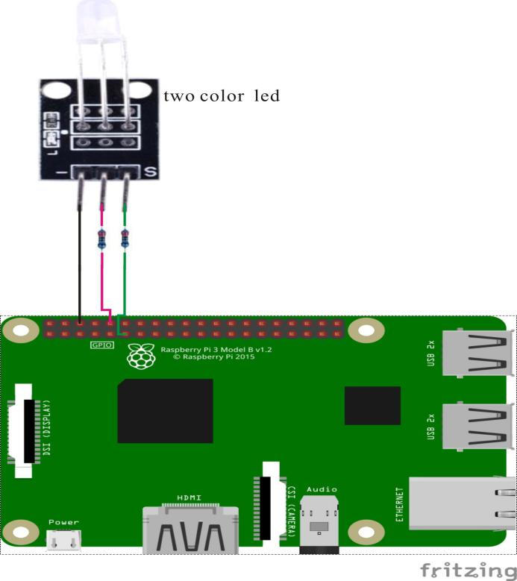

Three-color LED pin position:

“S” (right) ↔ Raspberry Pi pin 11

“ “ (middle) ↔ Raspberry Pi pin 10

“-“ (left) ↔ Raspberry Pi GND

Sample code

Python Code

#!/usr/bin/env python

import RPi.GPIO as GPIO

import time

colors = [0xFF00, 0x00FF]

pins = {'pin_R':10, 'pin_G':11} # pins is a dict

GPIO.setmode(GPIO.BOARD) # Numbers GPIOs by physical location

for i in pins:

GPIO.setup(pins[i], GPIO.OUT) # Set pins' mode is output

p_R = GPIO.PWM(pins['pin_R'], 2000) # set Frequece to 2KHz

p_G = GPIO.PWM(pins['pin_G'], 2000)

p_R.start(0) # Initial duty Cycle = 0(leds off)

p_G.start(0)

def map(x, in_min, in_max, out_min, out_max):

return (x - in_min) * (out_max - out_min) / (in_max - in_min) + out_min

def setColor(col):

R_val = (col & 0xFF00) >> 8

G_val = (col & 0x00FF) >> 0

R_val = map(R_val, 0, 255, 0, 100)

G_val = map(G_val, 0, 255, 0, 100)

p_R.ChangeDutyCycle(R_val) # Change duty cycle

p_G.ChangeDutyCycle(G_val)

try:

while True:

for col in colors:

setColor(col)

time.sleep(0.5)

except KeyboardInterrupt:

p_R.stop()

p_G.stop()

for i in pins:

GPIO.output(pins[i], GPIO.HIGH) # Turn off all leds

GPIO.cleanup()

C code

#include <wiringPi.h>

#include <softPwm.h>

#include <stdio.h>

typedef unsigned char uchar;

#define LedPinRed 16

#define LedPinGreen 0

void ledInit(void)

{

softPwmCreate(LedPinRed, 0, 100);

softPwmCreate(LedPinGreen,0, 100);

}

uchar map(uchar val, uchar in_min, uchar in_max, uchar out_min, uchar out_max)

{

uchar tmp = 0;

tmp = (val - in_min) * (out_max - out_min) / (in_max - in_min) + out_min;

return tmp;

}

void ledColorSet(uchar r_val, uchar g_val)

{

uchar R_val, G_val;

R_val = map(r_val, 0, 255, 0, 100);

G_val = map(g_val, 0, 255, 0, 100);

softPwmWrite(LedPinRed, R_val);

softPwmWrite(LedPinGreen, G_val);

}

int main(void)

{

int i;

if(wiringPiSetup() == -1)

{

printf("setup wiringPi failed !\n");

return -1;

}

ledInit();

while(1)

{

ledColorSet(0xff,0x00); //red

delay(500);

ledColorSet(0x00,0xff); //green

delay(500);

}

return 0;

}

Technical Background

The 5mm two-color LED and 3mm two-color LED both use the same wiring diagram and sample code. Their physical parameters are slightly different:

|  |  |
| --- | --- |
| ◆ Diameter: 5mm ◆ Emission Color: Green + Red ◆ Emission Angle: ◆ Wavelength: G:571nM R:625nM  ◆Luminous Intensity:  G:20mcd-40mcd; R:60mcd-80mcd  ◆ Forward Voltage:  G:2.3V-2.6V; R:1.9V-2.2V  ◆ Use Current: 20mA  ◆ Package Color: None  ◆ Package Type: Diffusion  ◆ Stand Type: Long Leg | ◆ Diameter: 3mm ◆ Emission Color: Green + Red  ◆ Emission angle: 150° ◆ Wavelength: G:571nM R:644nM ◆ Luminous intensity: G: 20mcd-40mcd; R:40mcd-80mcd ◆ Forward Voltage:  2.0V-2.5V  ◆ Use Current: 10mA  ◆ Package Color: None  ◆ Package Type:  ◆ Stand Type: Long Leg |